**Brooklyn torah gazette**

**For parshas mattos-masei 5779**

Volume 3, Issue 47 (Whole Number 144) 2 Menachem Av 5779/ August 3, 2019

**Printed L’illuy nishmas Nechama bas R’ Noach, a”h**

For a free subscription, please forward your request to [***keren18@juno.com***](mailto:keren18@juno.com)

**It’s in OUR Hands**

**By Rabbi Naftali Schiff**



The summer holidays start later for us that they do for everyone else. Summertime is relaxing, carefree, sunny and pleasurable. Yet we are tense, burdened, darkened and even uncomfortable over the next three weeks. The three weeks increase with intensity and tighter restrictions the closer we get to Tisha B’Av in order to sensitize us to that which we have lost. The three weeks are heavy and there is no way of escaping that.

At the same time, it’s not simply about remembering and mourning the past. If it was, perhaps we could allow ourselves to forgive, forget and finally move on after 1951 years. Rather we recall the past in order to right an historic wrong. We go through these practices so that we never arrive at a sense of acceptance with our exile.

Tragically, the majority of Jews who replaced Yerushalayim with Berlin, Moscow or any other cultural or ideological capital have not remained part of the Jewish People. It is as if the pasuk ‘If I forget you Yerushalayim’ has an even greater effect than just the right hand forgetting its cunning.

The tears that we shed at this time have less to do with crying over the past, than crying for the present and the future. This is beautifully expressed by the following idea: Moshe Rabbeinu was sent down the river as a young baby, Pharaoh’s daughter heard his cry and immediately identified him as being a Jewish child.

The Nesivos Shalom explains that from his cry it was evident he was a Jew because we don’t cry out of despair, rather his tears were tears of hope. We cry because we understand that Galus is an ongoing process and since every generation that does not have the Beis Hamikdash rebuilt is as if we have destroyed it, we recognize that it’s in our hands.

What is fascinating is that even in the years immediately following the exile and dispersion, the focus at this time was never to direct anger at our attackers. The Jewish way has never been to point the finger at anyone other than ourselves. It is as if we are aware that our history and destiny ought to be unique.

If Hashem can allow the forces of nature to overcome us and subject us to the natural order of conquest and destruction, then we have taken an honest look at ourselves and see where we have gone wrong. The Rambam writes that it is this introspection that ought to be the focus of our fasting and the Gemara is specific about the spiritual and ethical challenges that the Jewish People [have to deal with.]

In fact almost counter intuitively, the three cardinal transgressions of idolatry, adultery and murder [that was the cause of the destruction of the First Beit Hamikdash] were rectified a mere seventy years later, whereas baseless hatred as embodied by the story of Kamtza and Bar Kamtza [that caused the destruction of the Second Beis Hamikdash] is still endemic.

It is fascinating that the word Kamtza is related to the word kometz which means ‘full hand’. The whole tragic episode is one of selfishness and disregard for others and their feelings. This selfishness is actually something innate, as babies we are born with closed fists, as we get older we grab things towards us and it takes a lifetime to develop the altruism that befits people who were created in the image of Hashem.

This resonates not only on a personal level, but also on a national level. As long as our palms are closed, not only will the Beis Hamikdash remain in ruins, but it is as if we have destroyed it with our own hands. It is perhaps for this reason that Yeshayahu Hanavi, the one who experiences a chazon, a vision with his heart, perceiving the inner workings of the nation, concludes his opening prophecy with the immortal words:

Hashem. ציון במפשט תפדה ושביה בצדקה destroyed His home rather than His people in order for us to wake up and build from the inside out, to remind us that our natural state is one of unity, love. Justice and tzedaka and to enable us to connect with it and implement it into our lives. And if we open our hearts and hands then maybe this year we won’t have to fast on Tisha B’Av.

*Reprinted from the Parshas Pinchas 5779 email of Oneg Shabbos (London, England.) Rabbi Schiff is the founder and Chief Executive of Jewish Futures.*

**The Shmuz onParshas Matos/Maasei**

**Two Elements to a Sin**

**By Rabbi Bentzion Shafier**

**Founder of TheShmuz.com**

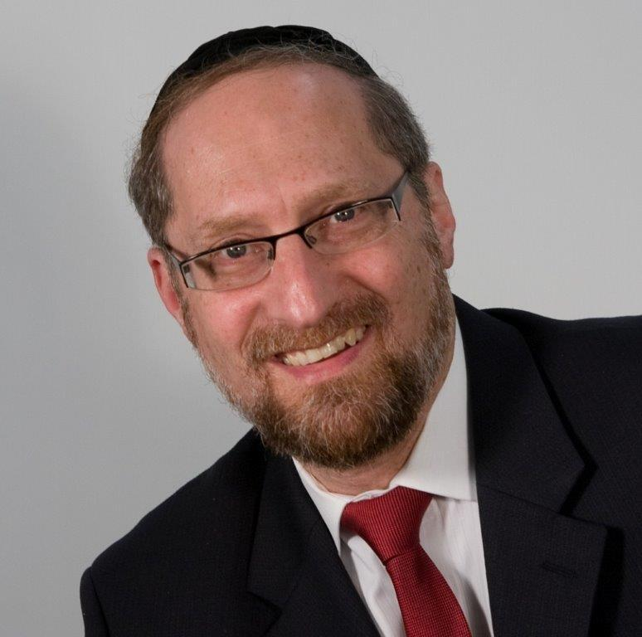

“And if her father will revoke [the neder] the day that he hears all of the vows and prohibitions that she placed on herself, they [the vows] will not stand, and HASHEM will forgive her because her father annulled them.” — Bamidbar 30:6

While a neder is a Halachically binding vow, there are methods to annul it. For example, if a husband becomes aware of his wife’s neder and feels it is inappropriate, he can refuseit, rendering it not binding. This refusalcan be done with or without her knowledge. The Torah states that if a husband refuses his wife’s neder, HASHEM will forgive her.

Rashi is bothered by the expression, “**HASHEM will forgive her.**” If a woman made a neder and her husband annulled it, there is nothing binding upon her. What does she need forgiveness for?

Rashi explains that this is speaking of a case in which a woman made a neder, her husband overheard and annulled it, but she was unaware of it. In her mind, the neder still stood. If she then went and violated her neder, if she did that which she vowed not to do, even though her neder was absolved, she still needs forgiveness.

This explanation seems difficult to understand. If, in fact, her husband successfully undid the neder, then it wasn’t binding. If so, she did nothing wrong. The question remains: what does she need forgiveness for?

I sat down to eat a cheeseburger, and it turned out to be soy cheese

This is equivalent to a situation in which, for whatever reason, I decide to eat a cheeseburger. After finishing it, I find out that it wasn’t really a cheeseburger. Unbeknownst to me, someone switched the cheese for an imitation cheese product made of soy beans.

The meat was kosher, and the fake cheese wasn’t dairy. The sandwich turns out to be kosher. In that case, I didn’t eat treif, and I shouldn’t need atonement. So too with the woman whose husband annulled her vow. Even though she may not have been aware of it, she didn’t violate her word, and she shouldn’t need forgiveness.

**Two Elements to Every Sin**

The answer to this question is that there are two elements to every sin. The first element is the damage that it does to me. HASHEM gave the Torah as the **ultimate system of self-perfection**. Each mitzvah is part of the program that helps me grow and shapes me into who I will be for eternity. On the flip side, each aveirah damages me. Each sin has been singled out by the Creator as containing the ingredients to both impede my spiritual growth as well as to directly damage me.

We may not recognize the adverse effect of eating forbidden foods, but they leave an indelible imprint. The Gemara tells us that treif foods deaden the heart. When I consume them, it becomes more difficult for me to experience HASHEM’s presence. Treif foods make it more difficult for me to feel Shabbos. They make it harder for me to experience another Jew’s pain. For that reason, HASHEM forbids us to eat them and warns us against them.

That is the first element to every sin — the direct damage it has on me. But every sin has a second element to it: I was commanded by my Creator not to do it.

HASHEM created me, maintains my existence, provides my sustenance, and watches out for my best interests 24/7. That alone is reason enough for me to obey HASHEM.

However, even if HASHEM wasn’t as involved in my life as He is, just the fact that the great King of Kings, the Master of the Universe has commanded me in something obligates me in it. Whether I am aware of the reason or not, whether there **is** a reason or not, if the King has commanded me in a given action, I am obligated to fulfill it. If I violate the will of the King, that is considered an audacious act.

This seems to be the answer to question on Rashi. In the case of the woman whose neder was annulled, she was unaware that her husband undid it. In her mind, the vow still stood. So in her mind, what she was doing was forbidden. She was violating the command of the King.

Granted, she got **lucky**, and the actual damage of the sin wasn’t there, but that’s only because the essence of the neder was gone. She still acted against what she understood to be the King’s command. She showed disregard for the King’s wishes, and for that, she requires kapparah.

This concept has great relevance to us. Many times we take the attitude that mitzvahs are good things to do because they benefit and help us. Much like eating well and exercising, we see mitzvahs as things that we really should do. And while that is true, there is an entirely different dimension to our fulfilling mitzvahs, and that is that we are commanded in them. The word “mitzvah” comes from the root “command.” Mitzvahs aren’t suggestions, and they’re not recommended procedures. We are obligated.

I don’t have that prerogative when it comes to mitzvahs. Even though HASHEM gave them to me for my growth and my good, I didn’t choose the program, nor was I given the right to opt out. Whether I like it or not, HASHEM has put me on this track of success. Whether I am pleased with it right now or not, the King has commanded me in the various activities that are for my good.

HASHEM commanded us in activities and a lifestyle that is for our benefit, and even if we don’t fully recognize their value and preciousness now, there will come a time — whether in this life or perhaps only when we leave this earth — that we will recognize the extraordinary value and preciousness of every mitzvah. Then, we will thank HASHEM for putting us on the track towards greatness. For that reason, HASHEM commands us to keep the mitzvahs — with the understanding that at some point we will be eternally grateful for the great opportunity called life.

*Reprinted from this week’s website on TheShmuz.com This is an excerpt from the [Shmuz on the Parsha book](https://theshmuz.com/product/shmuz-on-the-parsha-book/).*

**The Jew’s Mission to Uncover**

**The Soul’s Hidden Strengths**

**From the Talks of the Lubavitcher Rebbe**

**Rabbi Menachem Mendel Schneerson, Zt”l**

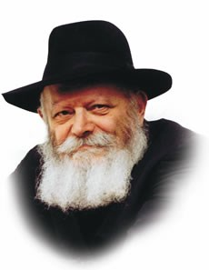

In the Torah, two different names are used to refer to the tribes of Israel--"shevatim" and "matot" (as in the name of the first of the two Torah portions read this week, "Matot"). "Shevet," literally a staff and "mateh," literally a rod or stem, both denote the branches of a tree. The difference between them is that a shevet is a supple branch, attached to a living tree, whereas a mateh is a hardened stick already cut from the trunk.

The two names used to denote the Jewish tribes have spiritual significance, and refer to the type of connection every Jew has with G-d, symbolized by the tree. When the connection between the Jewish soul and its G-dly source is open and revealed, the word shevet is used.

**The Hidden and Obscured Bond**

**Between the Jew and G-d**

When, however, the bond between the Jew and G-d is hidden and obscured, the word matot is used to describe the Jewish people.

In general, the first description refers to the Jewish soul as it exists before coming down into the physical world. The soul, united with G-d, is directly connected to its source, just as the branch is still connected to its source of life, the tree.

After the soul makes its descent into a physical body, however, it more closely resembles the mateh which has been severed from the trunk. The vital connection to its source, to G-d, is no longer easily perceived and apparent, so much so that the soul may feel as if it has been totally cut off, G-d forbid. The afflictions of the physical body and the demands of the material world harden the tender soul, making it tough and less sensitive to spirituality.

**The Advantage of the Mateh Over the Shevet**

Yet despite the fact that the shevet is still connected to its source, it is not as strong and rigid as the superior mateh, which has been tempered by its experience. The branch, while attached to the tree, is green and flexible. Only after it is cut off does it become a sturdy and dependable rod.

This, in essence, is the purpose for which the soul is sent down into this world and distanced from its G-dly source--to uncover the soul's hidden strengths and enable it to reach an even higher level of spiritual closeness to G-d than before. When the soul overcomes the challenges of the Evil Inclination and the hardships of a physical existence, its bond with G-d becomes infinitely stronger and deeper.

The distinction between shevet and mateh exists on another level, too. When the Holy Temple existed and G-dliness openly illuminated the world, the Jewish people were on the level of shevet.

**When Moshiach Arrives the Hidden**

**Godliness in Creation will be Revealed**

After the destruction, however, and the advent of the dark and bitter exile, we find ourselves on the level of mateh. For almost two thousand years the Jewish people have had to develop its hidden resources and stand strong in the face of suffering.

When Moshiach comes and the G-dliness which is concealed within all of creation is revealed, the Jewish people, through having uncovered the "mateh" within their souls, will enjoy an even closer relationship with G-d, the true purpose of the entire exile.

*Reprinted from the Parashat Mattos-Masei 5753/1993 edition of L’Chaim Weekly (Issue #275), a publication of the Lubavitch Youth Organization in Brooklyn, NY.*

**Rav Avigdor Miller on**

**Loyalty to America**

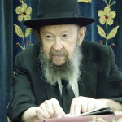

**QUESTION:** Should a person feel loyalty to America, and if yes, how should that loyalty be expressed?

**ANSWER:** Should a person feel loyalty, let’s say, to a place where he stopped when it was raining and they gave him a roof over his head? Should you be loyal to the one who gives you that place to stay dry? Certainly! You have a place of refuge from the rain and you should be grateful for that.

Now, America is a place of refuge for us. We came here from the lands of persecution. Not only those who came as a result of Hitler, but even those who came earlier, from Czarist Russia and other European countries - they came to a land of equal opportunity. They were amazed at the friendliness here. Our fathers, when they came to America they were overjoyed. They kissed the earth in happiness.

The American flag is a sign of decency and compassion. That’s what it is. Of course, it’s only a symbol, but it’s a symbol of what Hakodosh Boruch Hu is doing to us. America is a great gift to us from Hakodosh Boruch Hu.

And therefore it’s not America that we have to love; we have to love Hashem who gave us America! And if Hakodosh Boruch Hu gives you Australia, then you have to love Hakodosh Boruch Hu who is giving you Australia.

Now, there’s a principle: if you drink from a well, don’t throw dirt into it (Bava Kama 92b). You have to preserve that well. And even though a well is an inanimate object, you should show gratitude to it. It’s a principle - you must show gratitude even to an inanimate object. That’s a principle of the *gemara!* A well from which you drank, don’t spit into it and don’t throw dirt into it. Show gratitude towards the well.

And so all of us should be grateful to America. But it’s not America - it's Hashem who gave the gift to us. So let’s try to maintain that gift and make sure that the liberals don’t ruin it.

And so certainly we have to be loyal and grateful to America. But America is only a symbol - who’s America after all? This goy or that goy? America is Hakodosh Boruch Hu’s gift to us and it's our responsibility to appreciate that gift. And therefore we have to cooperate with America and try to preserve it.   
TAPE # 701 (July 1988)

*Reprinted from the July 22, 2019 email of Toras Avigdor (Tape #701).*

**Rabbi Berel Wein on**

**Parashat Matot**

The word for a staff, stick or even a scepter is the same word –mateh – that is used to describe the tribe or an integrated group of people. As has been often noted, the Hebrew language is rather sparing in its vocabulary. Therefore, often the same word is used with other meanings in different circumstances. But there always is a connection between the various uses of the word in different literary context.

Simply put, a tribe or group of people -- no matter how talented and capable they may be individually -- still requires a leader, someone who will wield a staff and a scepter over them. The great analogy of this is a symphony orchestra, where each one of the musicians performing in that orchestra is immensely talented. But, for the orchestra to perform correctly, it requires a conductor to wield a baton.

In music and in the performance of a philharmonic orchestras, all the written notes are always the same. But it is the genius of the conductor that transforms the written notes into a soaring performance. It is the conductor that hears and anticipates the correct moment and instance where the individual musical instruments should be introduced. It is the baton of the conductor that creates and directs the sound and music of the orchestra. So, too, it is the tribal leader, who wields the staff of leadership that creates the identity and definition of the tribe itself.

It is perfectly understandable why Moshe should gather the heads of the tribes of Israel together to inform them regarding the laws of vows and verbal commitments. For, if the leaders of the tribe are themselves lacking in fulfilling their promises, commitments and sworn oaths, then certainly the tribe that they lead will also not be trustworthy in the long run. Leaders lead not only by thoughts and ideas but, even more so, by verbal commitments and action.

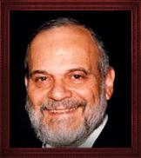

**Rabbi Berel Wein**

Deeds certainly speak loudly, but words are of great consequence as well. The words that we use define us and let others know what we are. Verbal commitments should be made sparingly and carefully, for they are truly the batons of leadership. This is true for parents and family life as well – never promise children things or items that are beyond one's reach or control. The same can be said of the commercial world as well.

Unfortunately, we have learned that in the political and diplomatic world, words are not necessarily to be believed or acted upon. However, the standards of Torah do not allow for such laxity -- no matter how negative the consequences may be -- for fulfilling one's stated commitment.

This has to be taught to the people by the leadership of the family, tribe and community. And, the Torah does not naïvely assume that this is something which will be self-understood. Knowing human nature for what it is, the Torah chooses to emphasize this point in its choice of words and subject that constitute the opening section of this week's reading.

*Reprinted from this week’s website of Rabbiwein.com*

**18 Ways to More Effective**

**Prayer (Part One)**

**By Rabbi Moshe Meir Weiss**

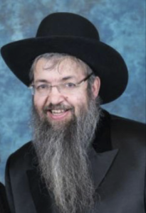

The Torah informs us that before Balak commissioned Bilam to curse Klal Yisroel, he spoke to the elders of Midyan. Rashi adds, Why did Balak seek advice from Midyan?

Rashi answers that when Balak saw the incredible conquests of Moshe Rabbeinu, he started to do research about him. He discovered that Moshe Rabbeinu spent his formative years in Midyan. He therefore inquired from them what they thought Moshe’s special powers were.

The Midyanites definitively answered, “Ein kocho ela b’feh – His strength is only with the mouth.” Similarly, in Parshas Masei, Rashi informs us that the umnos, the craft of the B’nai Yisroel is with the mouth.

He elaborates, “Al yedei tefila u’bakasa – Through prayer and requests.” Rashi goes on to say that because Bilam usurped the ammunition of the Jews and tried to harm us with the mouth, measure for measure we adopted the ammunition of the goyim, namely the sword and Bilam ben Beor hargu b’chorev – Bilam the son of Beor was slain by the sword.

Thus we see that our nation’s strength is not with bows and arrows, spears and shields, nor with tanks and jets. Rather, as Dovid HaMelech says, “Eila b’rechev v’eila basusim v’anachu b’Sheim Hashem Elokeinu nazkir – There are those who come with chariots and others with mighty steeds, but we come with the Name of Hashem our G-d.” This sentiment is also echoed in the famous verse, Hakol kol Yaakov v’yadaim yedei Esav – The voice is the voice of Yaakov while the strength of Esav lies in his hands.”

Although our wonderful and brave IDF is a marvelous example of proper hishtadlus, similar to the loyal, skilled and courageous chaiyalim of King Dovid, they were always aware that they drew their strength and were fueled by the tefilos of Klal Yisroel.

Indeed, when Moshe Rabbeinu sent twelve thousand elite soldiers to conquer Midyan, it says, “Elef l’mateh, elef l’mateh – A thousand for each tribe, a thousand for each tribe.” It seems like mere repetition.

However, the Das Zekeinim miBalei Tosefos explains for every thousand warriors there was a corresponding thousand tefilah specialists who prayed for them at home, thus emphasizing the idea that success in the battlefield was primarily determined by the heartfelt prayers of the Jewish people.

Indeed, the very emblem of King Dovid, the six-sided star of David, stood for echad l’malah v’echad l’mateh v’arbeh ruchos, that they realized that their strength lay in Hashem who rules above and below and in all four directions.

Rashi teaches us that our national power is with our mouths through the craft of prayer and request. Since Rashi calls it a profession, it means that we have to study it and learn its many skills like we would learn if we were studying to become a doctor or a lawyer. In the next series of articles, with the help of Hashem I hope to give you an in-depth course in the many facets of this unique profession. In the merit of learning our national skill set, may Hashem bless us with long life, good health, and everything wonderful.

*Reprinted from the Parshas Pinchas 5779 email of the Jewish VUES.*

**Sages through the Ages**

**Rabbi Yosef Caro**

**By Dr. Benji Schreiber**

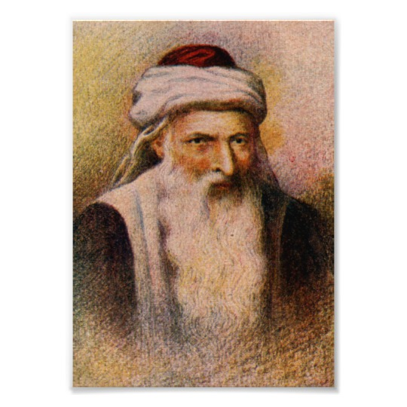

Rav Yosef Caro was born in Toledo, Spain [in 1488] just four years before the expulsion. His family wandered to Lisbon, Portugal and eventually to Kushta, now Istanbul, Turkey. He was educated by his father, Rabbi Ephraim, a scholar in his own right, who was later appointed chief rabbi of Nikopol, Bulgaria.

After his father passed away, he lived in the home of his uncle, Rabbi Yitzchak Caro, who adopted him as his own son. He eventually moved to Adrianople (now called Edirne), also in Turkey, where he married the daughter of a scholar named Rabbi Chaim ibn Albalag.

He soon established a Beit Midrash in Adrianople. From 1523-1536 he lived in Nikopol, Bulgaria where he set up a Bet Yosef yeshiva and school. From there he went to Tzefas in Eretz Yisrael. In 1564 Rav Caro’s second wife, who had borne him his son Shlomo, died. He then married the daughter of Rabbi Zecharia ben Shlomo Zavasil Ashkenazi, one of the sages of Jerusalem. When he was in his ninth decade, his wife bore him another son, Yehuda.

After the Mahari Berav left Tzefas in 1538, Rav Caro was seen as the leader of the scholars of Tzefas. He served as head of the communal council of Tzefas, and led a yeshiva of approximately 200 talmidim. He wrote hundreds of teshuvos, responsa to halachic questions from all over the Diaspora.

Kesef Mishna His first major work was the Kesef Mishna, a commentary on the Rambam’s Mishneh Torah, particularly identifying the Rambam’s sources and defending the Rambam against the attacks of the Raavad.

He began his major work, the Bet Yosef, a commentary on Rav Yaakov ben Asher’s Arba’ah Turim, in 1522, when he was 34 years old, and finished it 20 years later. He consulted 32 Talmudic and rabbinical sources and discussed every law, starting with its source in the Gemara, tracing its development, discussing every divergent view and finally ruling on the halacha.

His rulings were generally based on the majority view of Rav Yitzchak Alfasi (The Rif ), the Rambam and Rabbeinu Asher ben Yechiel (the Rosh), though he did retain some discretion to insert his own views, particularly when there was no clear decision.

The Beis Yosef was published in 1555. Shulchan Aruch Rav Yosef Caro wrote the Shulchan Aruch in 1563 and it was published in Venice in 1565. He wrote it as a concise version of the Bet Yosef, so that it could be widely learnt and revised in its entirety on a monthly basis!

He hoped the young students would learn it by heart. The Shulchan Aruch has arguably been the most widely accepted Halachic work ever. Rav Moshe Isserles, the Rama, wrote notes on the Shulchan Aruch to explain where Ashkenazi custom differed, and quoting Ashkenazi sources, especially the Baalei HaTosafos, the Maharil other late Ashkenazi Rishonim.

The Ashkenazim follow Rama where he disagrees with Shulchan Aruch. In addition to being a master of Halacha, Rav Yosef Caro was immersed in the study of Kabbalah. Parts of his personal diary were published as Magid Meisharim – records of his nightly meetings with a Heavenly angelic mentor who he believed to be nothing less than the Mishnah personified, which instructed him.

*Reprinted from the Parshas Pinchas 5779 email of Oneg Shabbos (London, England.) Rabbi Schiff is the founder and Chief Executive of Jewish Futures.*

**Rabbi Fischel Schacter Discusses the Importance**

**Of Appreciating Crumbs**

**By Daniel Keren**

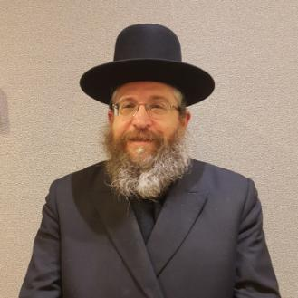

The second speaker at the Independence Day Hakhel Yarchei Kallah held at the Agudath Israel of Madison in Flatbush was Rabbi Fischel Schachter, internationally renowned Maggid Shiur. He spoke on the timely topic of “Practical Ideas for a Successful Summer.”

It is those moments between ourselves and Hakodesh Baruch Hu that truly defines a person. A Jew is a Jew and no matter how much one tries to change that fact, it just won’t happen.

The Vilna Gaon teaches that the Torah that one studies reveals to us the purpose of our lives. A difficult nisayon (challenge) in life is a telegram or opportunity from the Higher Heavens.

When a person learns Torah with mesira hanefesh (self-sacrifice) this helps one to clarify all of the contradictions that were previously confusing his personal life. The sefer Michtam Me’Eliyahu (written by Rabbi Eliyahu Dessler, 1892-1953) teaches us that how one can overcome our nisoyanim is to reflect on our potential [spiritual] greatness.

**Don’t Disregard the Crumbs**

No matter how difficult one’s life is, a person should always do what one can do. If for example you go to a Daf Yomi shiur and can only comprehend just 5% of the class, grab the opportunity to take that 5%. Don’t disregard the crumbs.

Crumbs are important. Rabbi Schachter emphasized that crumbs must never just be thrown away. One who throws away crumbs from the table onto the floor brings upon himself the spiritual punishment of becoming impoverished.

If you want to study a daf of the Talmud and you don’t think that you have the time at night do accomplish that goal, tell yourself that you will just learn for 15 minutes. Grab those crumbs. And you might discover that you are halfway through comprehending the daf and you will find that desire to finish the daf that same evening

Rabbi Moshe Wolfson, Rav of Beis Medrash Emunas Yisroel in Boro Park learns from Parshas Shelach Lecha that we all have an important mission in our life. Hashem sends a person to where his tafkid is (his purpose in life.)

**The Best Place that You Can Possibly Be**

Rav Wolfson teaches the important lesson that wherever one happens to be should be in that person’s life the best place that one could possibly be at that moment. So if you want to be in the Catskills but are stuck this summer in Brooklyn, appreciate the benefits. You can easily find parking in the summer. When you go shopping, the merchants who during the year are harried and bark at you, are actually polite and happy to see you.

If somebody in your life is hurting you and causing you terrible pain, don’t strike back at them but rather use this precious opportunity to try and understand why that person is acting against you so harshly. And that attempt to understand the pain in your life is the success to your existence at this moment.

*Reprinted from the July 25th edition of the Flatbush Jewish Journal.*